WEEK-8 MONGODB

1. Create a database “Student” with the following attributes Rollno,

Age, ContactNo, Email-Id.

db.createCollection("Student");

show dbs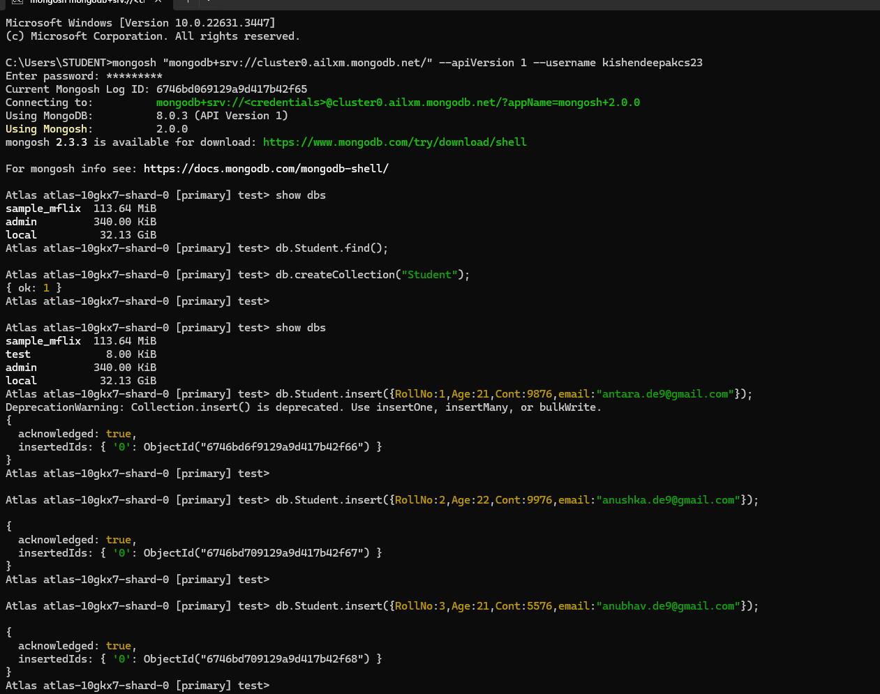

Insert appropriate values(at least 5)

db.Student.insert({RollNo:1,Age:21,Cont:9876,email:"antara.de9@gmail.com"});

db.Student.insert({RollNo:2,Age:22,Cont:9976,email:"anushka.de9@gmail.com"});

db.Student.insert({RollNo:3,Age:21,Cont:5576,email:"anubhav.de9@gmail.com"});

db.Student.insert({RollNo:4,Age:20,Cont:4476,email:"pani.de9@gmail.com"});

db.Student.insert({RollNo:10,Age:23,Cont:2276,email:"rekha.de9@gmail.com"});

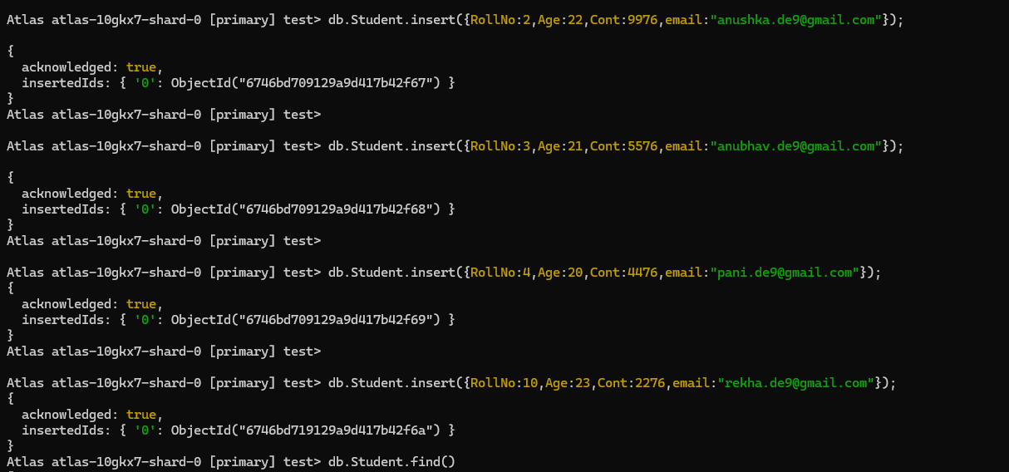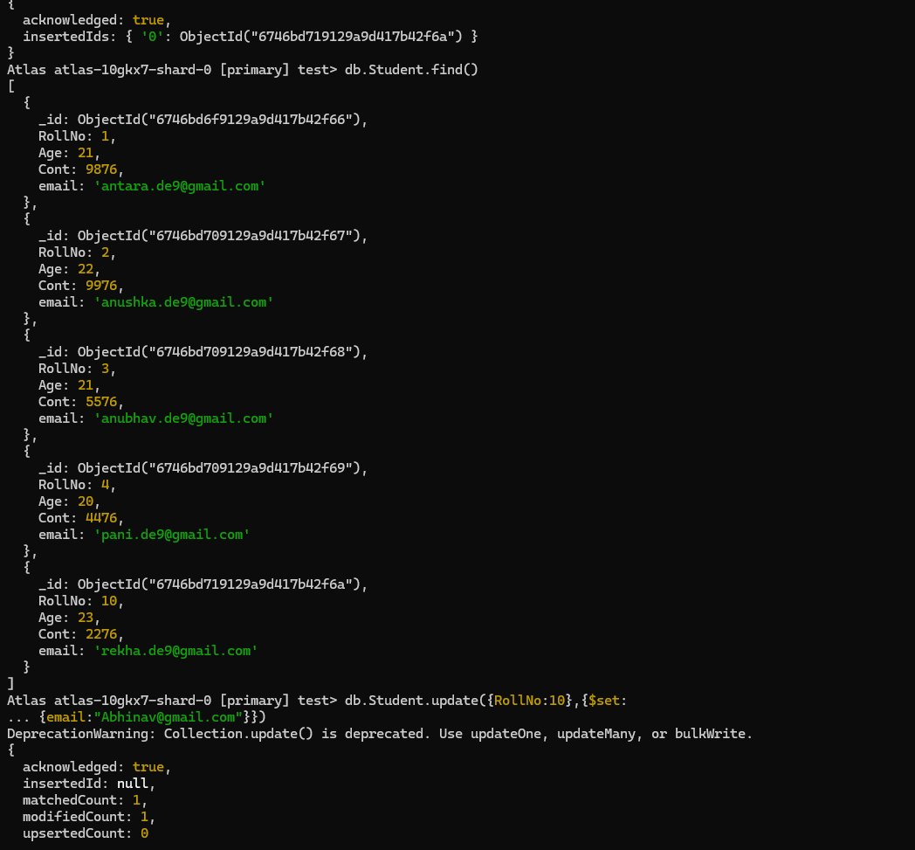

View the data

db.Student.find()

Write query to update Email-Id of a student with rollno 10.

db.Student.update({RollNo:10},{$set:

{email:"Abhinav@gmail.com"}})

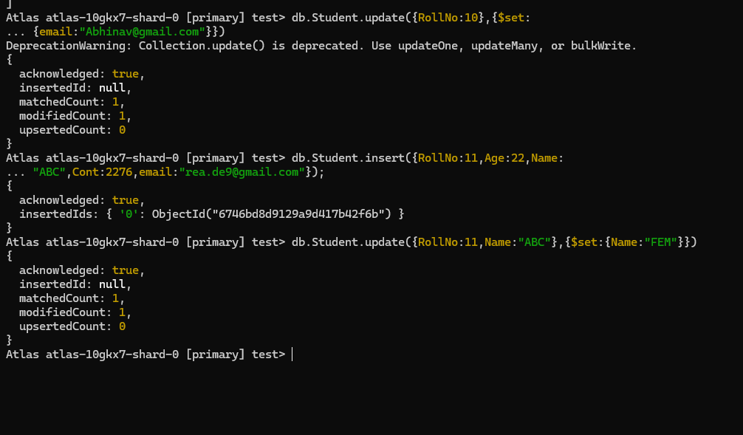

Replace the student name from “ABC” to “FEM” of rollno 11.

Insert appropriate data:

db.Student.insert({RollNo:11,Age:22,Name:

"ABC",Cont:2276,email:"rea.de9@gmail.com"});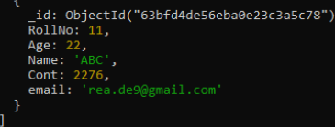

Replace the student name from “ABC” to “FEM” of rollno

11.(1)

Replace Query:

db.Student.update({RollNo:11,Name:"ABC"},{$se

t:{Name:"FEM"}})

